Table 1: Number of genotypes showing significant (p<0.05) transgressive segregation from the parents for leaf angle across the three different growth stages for greenhouse and field experiments.

 | GH-09ª |  | GH-10ª |  | Field_10
 | Strongfield | Blackbird | Strongfield | Blackbird | Strongfield | Blackbird
Mean leaf angle | 160 | 148 | 149 | 90 | 130 | 124
Heading_FL^{b} | 0 | 2 | 6 | 0 | 0 | 3
Heading_2L^{b} | 4 | 1 | 0 | 1 | 0 | 5
Anthesis_FL^{b} | 0 | 10 | 0 | 4 | 8 | 11
Anthesis_2L^{b} | 0 | 2 | 0 | 0 | 0 | 8
Late_FL^{b} | - | - | 1 | 0 | 40 | 35
Late_2L^{b} | - | - | 54 | 0 | 0 | 28

ª GH = greenhouse; 09 = 2009, 10 = 2010.

^{b} FL = Flag leaf, 2L = Penultimate leaf; Late = Late milk stage.

Table 2: Number of effective factors involve in each growth stage over the three environments.

 | Effective Factorsª | Effective Factors^{b}
Heading_FL^{c} | 9-18 | 13-40
Heading_2L^{c} | 16-20 | 39-45
Anthesis_FL^{c} | 3-6 | 8-14
Anthesis_2L^{c} | 7-9 | 14-22
Late_FL^{c} | 0-2 | 2-4
Late_2L^{c} | 0-3 | 0-7

ª Range effect factors calculated following Snape et al., 1984.
^{b} Range effect factors calculated following Choo and Reinbergs 1982.
^{c} FL = Flag leaf, 2L = Penultimate leaf; Late = Late milk stage.

Table 3: QTL controlling leaf angle in 90 doubled haploid lines of the Strongfield/Blackbird population for greenhouse 2009, 2010 and the 2010 field experiment using composite interval mapping in MapQTL. QTL were identified by LOD scores greater than the threshold for Stage-of-Growth and Leaf-Position. Chromosome location and R² describing the proportion of phenotypic variance explained by the QTL are also provided.
Environmentª | Chromosome | Growth Stage and Leaf^{b} | Locus | Threshold^{c} | LOD^{d} | R²(%)^{e} | QTL
GH-09 | 2A | Anthesis_2L | Xwmc601 | 3.1 | 3.9 | 18.4 | QLa.spa-2A
GH-09 | 2A | Anthesis_2L | Xgwm630 | 3.1 | 3.9 | 18.4 | QLa.spa-2A
GH-10 | 2A | Anthesis_2L | Xwmc601 | 2.7 | 3.3 | 15.5 | QLa.spa-2A
GH-10 | 2A | Anthesis_2L | Xwmc630 | 2.7 | 3.3 | 15.5 | QLa.spa-2A
GH-10 | 2A | Late_2L | Xwmc601 | 3.1 | 4.3 | 19.5 | QLa.spa-2A
GH-10 | 2A | Late_2L | Xwmc630 | 3.1 | 4.3 | 19.5 | QLa.spa-2A
GH-10 | 2A | Heading_FL | Xwmc601 | 3.1 | 2.3 | 10.9 | -
GH-10 | 2A | Heading_FL | Xwmc630 | 3.1 | 2.3 | 10.9 | -
GH-10 | 2A | Heading_2L | Xwmc601 | 2.4 | 1.9 | 9.2 | -
GH-10 | 2A | Heading_2L | Xwmc630 | 2.4 | 1.9 | 9.2 | -
Field-10 | 2B | Heading_2L | Xwmc102 | 2.7 | 2.8 | 12.2 | QLa.spa-2B
Field-10 | 2B | Heading_2L | Xgwm55 | 2.7 | 2.7 | 12.0 | QLa.spa-2B
GH-09 | 3A | Anthesis_2L | Xgwm497b | 3.1 | 3.5 | 15.7 | QLa.spa-3A
GH-10 | 3A | Heading_2L | Xgwm497b | 2.4 | 3.7 | 16.5 | QLa.spa-3A
GH-09 | 3B | Anthesis_FL | Xbarc75 | 2.8 | 2.2 | 10.4 | QLa.spa-3B.1
GH-09 | 3B | Heading_FL | Xwmc418 | 2.9 | 4.7 | 20.0 | QLa.spa-3B.2
GH-09 | 3B | Heading_2L | Xcfa2134a | 2.7 | 3.5 | 16.9 | QLa.spa-3B.2
GH-09 | 3B | Anthesis_FL | Xcfd6b | 2.8 | 3.5 | 14.0 | QLa.spa-3B.2
GH-09 | 3B | Anthesis_2L | Xcfa2134a | 3.1 | 3.5 | 16.2 | QLa.spa-3B.2
Field-10 | 4B | Late_2L | Xwmc710 | 3.1 | 3.1 | 14.7 | QLa.spa-4B
GH-10 | 5B | Heading_2L | Xbarc128c | 2.4 | 11.3 | 37.2 | QLa.spa-5B
GH-10 | 5B | Heading_2L | Xgwm133a | 2.4 | 11.3 | 37.2 | QLa.spa-5B
GH-10 | 5B | Heading_2L | Xcfd219 | 2.4 | 10.9 | 35.4 | QLa.spa-5B
GH-10 | 5B | Anthesis_2L | Xbarc128c | 2.7 | 2.6 | 12.3 | -
GH-10 | 5B | Late_2L | Xgwm408 | 3.1 | 2.0 | 9.5 | -
Field-10 | 5B | Late_FL | Xgwm639 | 3.2 | 2.4 | 12.0 | -
Field-10 | 7A | Late_FL | Xbarc70a | 3.2 | 3.7 | 15.3 | QLa.spa-7A
GH-10 | 7A | Heading_FL | Xwmc139 | 3.1 | 1.8 | 8.9 | -
GH-10 | 7A | Anthesis_FL | Xwmc139 | 2.8 | 2 | 9.3 | -
GH-10 | 7A | Late_FL | Xwmc139 | 3.2 | 1.9 | 9.2 | -

ª GH = greenhouse; 09 = 2009, 10 = 2010.
^{b} FL = Flag leaf, 2L = Penultimate leaf; Late = Late milk stage.
^{c} MapQTL threshold based on 1000 permutations.
^{d} Logarithm of odds.
^{e} Phenotypic variance explained by the QTL.

Number of chromosomes with QTL for stage of development and leaf position combinations.
 | Penultimate leaf | Flag leaf
Heading | 4 | 2
Anthesis | 4 | 2
Late | 2 | 1

Table 4: Composite interval mapping analyses using MapQTL for detecting QTL controlling leaf length (Leaf_L) and leaf width (Leaf_W) trait in 90 doubled haploid lines of the Strongfield/Blackbird population.

Chromosome | Trait and yearª | Locus | Threshold^{b} | LOD^{c} | R²(%)^{d} | QTL
2B | Leaf_L09 | Xwmc592 | 3.0 | 2.9 | 10.4 | QLl.spa.2B.2
2B | Leaf_L10 | Xgwm148 | 3.0 | 3.7 | 13.0 | QLl.spa.2B.1
2B | Leaf_W10 | Xwmc102 | 3.0 | 3.8 | 14.5 | QLw.spa.2B.2
2B | Leaf_W10 | Xbarc183 | 3.0 | 3.1 | 11.4 | QLw.spa.2B.1

ª Leaf_L = Leaf length; Leaf_W = Leaf width.
^{b} MapQTL threshold based on 1000 permutations.
^{c} Logarithm of odds.
^{d} Phenotypic variance explained by the QTL.

Figure 1: Leaf angle between the stem and the mid rib of the ventral side of the flag leaf indicated by arrows at anthesis.
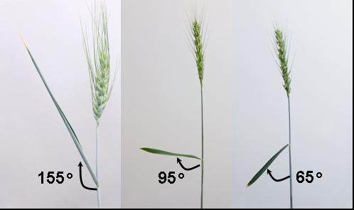

Figure 2: Frequency distribution of leaf unrolling response of the 90 lines of the Strongfield/Blackbird doubled haploid population for flag leaf (FL) and penultimate leaf (2F) at Heading, Anthesis and Late milk. The level of the parents are indicated (S-Strongfield, B-Blackbird) and the experiments are indicated on the left corner and designed with subscripts for greenhouse 2009 (1), greenhouse 2010 (2) and field experiment (3).

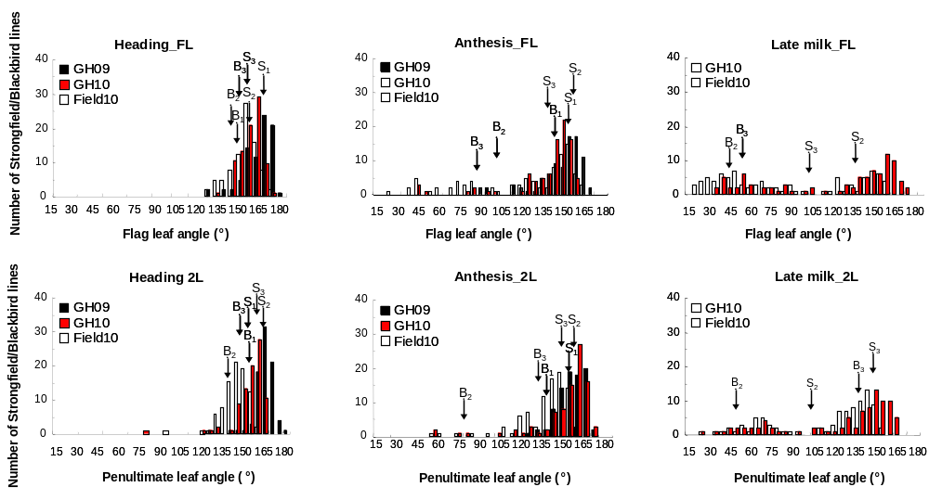

Figure 3: Location of significant leaf angle QTL in the Strongfield and Blackbird doubled haploid population for the chromosome 3B. The genome-wide threshold is market with dotted line. The LOD profiles of each position and growth stage with significant QTL are shown on the right corner.
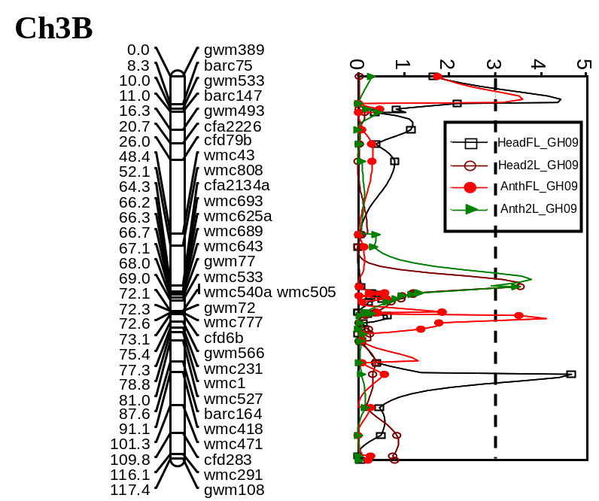

Figure 4: Location of significant leaf length and width QTL in the Strongfield and Blackbird doubled haploid population. The genome-wide threshold is market with dotted line. The LOD profiles of each position and growth stage with significant QTL are shown on the right corner.

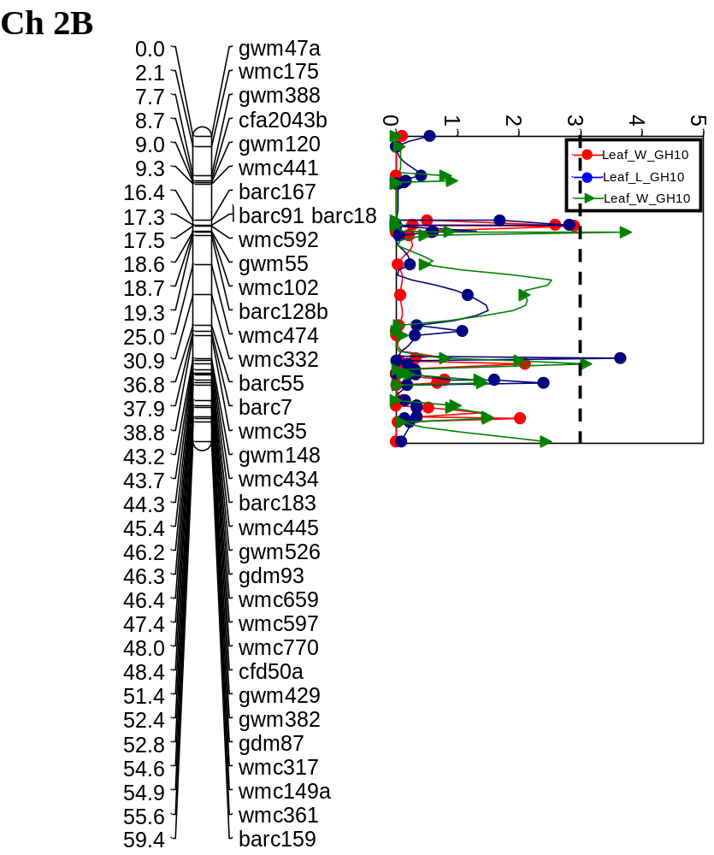

Table : Correlations of leaf angle for different growth stages taken on the Strongfield/Blackbird population least square means from environments greenhouse experiments 2009 and 2010.

 |  |  | Correlation coefficient (r)
 | ªHead_FL09 |  | Head_FL09
 | ^{b}Head_2L09 |  | 0.26**^{f} | Head_2L09
 | ^{c}Anthe_FL09 |  | 0.47*** | 0.24* | Anthe_FL09
 | Anthe_2L09 |  | 0.17NS | 0.55*** | 0.38*** | Anthe_2L09
 | Head_FL10 |  | 0.08NS | 0.27*** | 0.25* | 0.31** | Head_FL10
 | Head_2L10 |  | 0.05NS | 0.51*** | 0.07NS | 0.46*** | 0.42*** | Head_2L10
 | Anthe_FL10 |  | 0.08NS | 0.10NS | 0.25** | 0.20* | 0.47*** | 0.30** | Anthe_FL10
 | Anthe_2L10 |  | 0.13NS | 0.32** | 0.22* | 0.45*** | 0.42*** | 0.69*** | 0.36*** | Anthe_2L10
 | ^{d}Late_FL10 |  | 0.19NS | 0.21* | 0.29** | 0.19NS | 0.38*** | 0.36*** | 0.69*** | 0.30** | Late_FL10
 | Late_2L10 |  | 0.05NS | 0.26** | 0.26** | 0.42*** | 0.39*** | 0.47*** | 0.40*** | 0.61*** | 0.56*** | Late_2L10
ª Heading flag Leaf in greenhouse experiment 2009
^{b} Heading penultimate leaf in greenhouse experiment 2009
^{c} Anthesis flag leaf in greenhouse experiment 2009
^{d} Late milk flag leaf in greenhouse experiment 2009
^{f} The level of significance for each correlation is indicated by * - P<0.01, ** - P<0.01, *** -P <0.001. NS- Non significant

Table: Correlations of leaf angle for different growth stage taken on the Strongfield/Blackbird population least square means from field experiment 2010.

Correlation (r)
Correlated measures
ªHead_FL10 |  | Head_FL10
^{b}Head_2L10 |  | 0.13NS | Head_2L10
^{c}Anthe_FL10 |  | 0.38*** | 0.02NS | Anthe_FL10
Anthe_2L10 |  | 0.05NS | 0.59*** | 0.01NS | Anthe_2L10
^{d}Late_FL10 |  | 0.32** | -0.03NS | 0.71*** | 0.05NS | Late_FL10
Late_2L10 |  | -0.03NS | 0.50*** | 0.04NS | 0.51*** | 0.06NS | Late_2L10

ª Heading flag Leaf in field experiment 2010
^{b} Heading penultimate leaf in field experiment 2010
^{c} Anthesis flag leaf in field experiment 2010
^{d} Late milk flag leaf in field experiment 2010
^{f} The level of significance for each correlation is indicated by * - P<0.01, ** - P<0.01, *** -P <0.001. NS- Non significant

